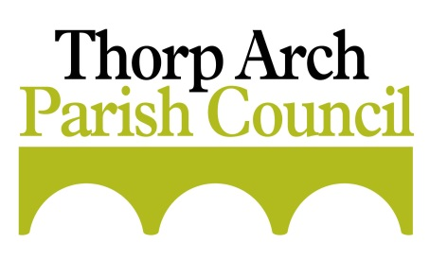
To Members of Thorp Arch Parish Council
You are hereby summoned to attend the next meeting of Thorp Arch Parish Council.
Members of the public and press are welcome to attend. Members of the public may make representations to the Council under item 4 according to the Council’s standing orders.
Agenda
For the meeting of the Council to be held at All Saints Church on
Tuesday 12th February 2019 at 7.00pm

- PUBLIC REPRESENTATIONS
- TO RECEIVE APOLOGIES AND APPROVE REASONS FOR ABSENCE
- POLICE MATTERS
- TO RECEIVE ANY DECLARATIONS OF INTEREST and CONSIDERATION of DISPENSATIONS
- TO APPROVE the MINUTES of the MEETING HELD ON MONDAY 14th JANUARY 2019
- TO CONSIDER CO-OPTION OF A NEW MEMBER TO THE COUNCIL
- TO CONSIDER NEW CORRESPONDENCE
- PARISH DEVELOPMENT MATTERS
- Neighbourhood Plan update
- To receive an update on the Leeds Site Allocation Plan
- Homes England Applications – Update on progress re: 16/03692 for 23 dwellings (now 18/07278/FU for 33 dwellings) and 17/07970 for 119 dwellings.
- To receive an update regarding fenced off land at Thorp Arch Grange
- To consider and decide upon the following Planning Matters:
- Ref: 19/00350/FU – Three detached kiosk units - Thorp Arch Waste Water Treatment Works Avenue E West Thorp Arch Trading Estate
- To receive an update on the ‘adverse possession’ title at North Lodge
- To monitor the Leeds United Training Ground application: Ref 18/06765/FU
- FINANCIAL MATTERS
- To authorise payment of accounts presented
- To note balances and receipts
- To receive the bank reconciliation
- To agree appointment of new internal auditor
- PARISH PROJECTS
  - To receive an update on the Heritage Board project
  - To receive an update on the War Memorial improvements
- COMMUNITY PARTICIPATION
- No items
- ORGANISATIONAL MATTERS
- To receive a report from the Outer North East Parish and Town Council Forum
- To receive an update on pruning work to trees
- Clerk briefing to Cllrs re May Elections
- INFRASTRUCTURE REPORT
- To receive information regarding matters relating to Highways and footpaths
- To receive an update on Speed Indication Devices (SID’s)
- To receive an update on a sign for The Village
- To discuss concerns regarding the new bridge on the Trading Estate
- ITEMS FOR NEXT AGENDA
Items to be raised here for the agenda for the next meeting, no decisions can be taken.
15. NEXT MEETING
The next meeting will be held on Monday 11th March 2019 at 7.00pm at All Saints Church.

T Wormley
Clerk to the Council
05/02/19
