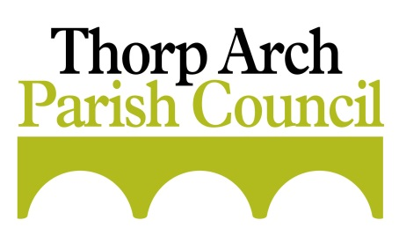
To Members of Thorp Arch Parish Council
You are hereby summoned to attend the next meeting of Thorp Arch Parish Council.
Members of the public and press are welcome to attend. Members of the public may make representations to the Council under item 4 according to the Council’s standing orders.
Agenda
For the Meeting of the Council to be held at All Saints Church on
Thursday 10th October 2019 at 7.00pm
- PUBLIC REPRESENTATIONS
- TO RECEIVE APOLOGIES AND APPROVE REASONS FOR ABSENCE
- POLICE MATTERS
- TO REVIEW COUNCILLOR’S REGISTER OF INTERESTS
- TO APPROVE the MINUTES of the MEETING HELD ON MONDAY 9th SEPTEMBER 2019
- TO CONSIDER NEW CORRESPONDENCE
- British Library visit
- PARISH DEVELOPMENT MATTERS
- Homes England Applications – Update on progress re: 16/03692 for 26 dwellings: 18/07278/FU and 17/07970 for 119 dwellings.
- To receive an update regarding fenced off land at Thorp Arch Grange
- To discuss outcomes from the Neighbourhood Plan Projects meeting
- To consider and decide upon the following Planning Matters:
- Ref: 19/03117/FU – Part two storey and part single storey extension to front and side, alterations to doors and windows; Gates and Railings to front - 17 Thorp Arch Park – Application withdrawn
- Ref: 19/05905/COND – Consent, agreement or approval required by conditions 8 and 9 of Planning Application 18/07278/FU - Land at Rudgate Park
- Ref: 19/05906/COND – Consent, agreement or approval required by condition 11 of Planning Application 18/07278/FU - Land at Rudgate Park
- FINANCIAL MATTERS
- To authorise payment of accounts presented
- To note balances and receipts
- To receive the bank reconciliation
- To organise a meeting to plan the 2020/21 budget
- PARISH PROJECTS
  - To discuss use for recently acquired land at North Lodge Green

- COMMUNITY PARTICIPATION
- To receive an update on the new noticeboard planning application
- To receive an update on historical rights of way
- To agree ordering of the Christmas tree
- To discuss the possibility of becoming a Dementia Friendly PC and actions required to achieve this
- ORGANISATIONAL MATTERS
- To receive an update on use of the school hall
- To consider the future of Causeway and PC communication with residents
- To receive an update on the template for the PC newsletter
- INFRASTRUCTURE REPORT
- To receive information regarding matters relating to Highways and footpaths
- To receive an update re hedges on Walton Road
- To receive an update on the Walton Road Speed Indication Device (SID)
- To consider information regarding 20mph campaigns led by residents
- To receive an update on the Sustrans cycle track
- To receive an update on Superfast broadband for Thorp Arch
- ITEMS FOR NEXT AGENDA
Items to be raised here for the agenda for the next meeting, no decisions can be taken.
14. NEXT MEETING
The next meeting will be held on Monday 11th November 2019 at 7.00pm at All Saints Church.

T Wormley
Clerk to the Council
03/10/19
