March Bulletin 2019

The following is a summary of some of the work the Parish Council (PC) has undertaken over the last few weeks. Please see our website for more information about the Parish Council, including minutes from meetings and agendas: www.thorp-arch.org.uk

Police Report – February
Only one crime reported for February: One theft from a vehicle on the Trading Estate.
Other news:
There were 44 crimes in February for the whole of Wetherby ward, 8 of these were burglary residential. There were 29 crimes in Harewood ward, 8 of these were burglary residential.
Security Advice:
Keeping children safe online – tips for parents:

- You have to be 13 years old you set up an account with YouTube, Snapchat, Facebook or Twitter without parent permission. You have to be 14 for LinkedIn and 16 for WhatsApp.

- Place the computer in a central area of your home where you can monitor it frequently. Get your children used to involvement early. Ask what they're looking at and finding, or who they're visiting.

- Warn your children frequently about the dangers of the internet, just as you warn them about the dangers of drugs, talking to strangers etc.

- Explain the importance of keeping personal information a secret - real names, home address, phone number, sports clubs etc.

- Tell your children never to respond to an angry, obscene or threatening message. Remind them to call you or another trusted adult if they come across something that makes them feel uncomfortable. Let them know that it’s not their fault if they receive bad messages.

- Make sure they have safe, strong and memorable passwords. Use symbols such as pa$$word (password) or @pple (apple)

- Make sure they have up to date antivirus software on computers, tablets and smartphones

- Check age ratings of games to ensure your kids aren’t accessing inappropriate content

- Tell them not to respond to bullying or other abuse on social media and when gaming and to tell you straight away if they are experiencing this

- Set privacy settings to the maximum

- Remind them that what goes on the internet stays on the internet

Make sure they:
- Never share images, send pictures or do anything on a webcam that they wouldn’t want family or friends to see and never share images of friends and family without their permission

- NEVER share rude images as you could be breaking the law (even if you didn’t take it, it was just sent to you)

For non-urgent issues and to pass on information, call West Yorkshire Police on 101.
In an emergency (if a crime is in progress or you think the offenders are nearby), call 999.
To give information anonymously, call Crimestoppers on 0800 555 111.
Remember you can report crimes and ASB online at https://www.westyorkshire.police.uk/report-it

Annual Parish Meeting – Save the Date!
This year the Annual Parish Meeting will be held on Monday 29th April 7.00pm at the school. Local organisations will be in attendance to talk about their work. The evening will provide the village with an opportunity to celebrate achievements through out the year. With this in mind, refreshments will be provided including wine, beer and soft drinks. Please put the date in your diary and join us.

Elections 2019
This year all Parish Councillors have to re-stand in the elections should they wish to continue. The elections will be held on 2nd May. There are five Councillor places. Four of our current Councillors intend to re-stand, one will not.
Anyone can apply to be a Councillor, providing they have lived or worked in the area for a minimum of a year. There are some other minor stipulations that the Parish Clerk can advise on. If you would like to join the PC and make a difference in your community, please contact the Clerk on clerk@thorp-arch.co.uk

20 MPH Zones in Thorp Arch
Leeds City Council plans to roll out 20mph speed limit zones across the city. The map below shows the current proposals for Thorp Arch. A four-week consultation period with communities has commenced. The Parish Council has been consulted and has submitted some amendments to the proposals including:

- Obligatory speed limit of 15 mph or 20 mph on Thorp Arch Bridge with new and better signage
- 30 mph speed limit on Dowkell Lane should be extended to junction with Walton Road/Church Causeway, rather than introducing a 40mph along the stretch of Dowkell Lane

The map is available to view on our website.

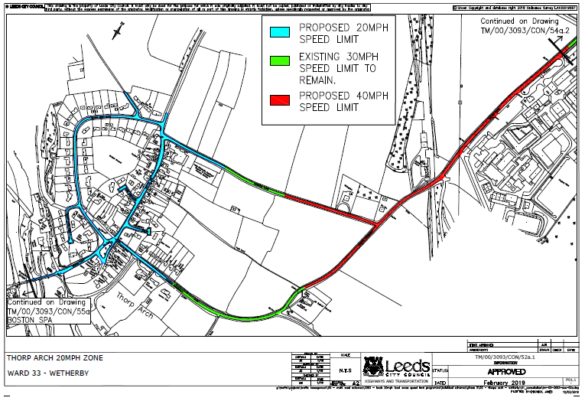

War Memorial Improvements
Many residents will now have seen the splendid improvements to the War Memorial. The improvements have been funded through a successful grant application made by the Parish Council. The area in front of the Memorial has been increased and laid with new paving to allow more space during memorial events.

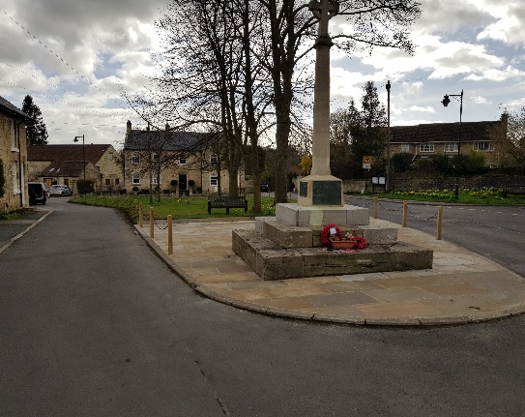

New Fencing around The Green
Following consultation with residents on The Green, the Parish Council agreed to reinstate the chain link fence to help protect both the Memorial and the grassed area from visiting vehicles, who have occasionally parked inappropriately or driven over parts of it. We are grateful for the many positive comments we have received about the new look Green!

Heritage Board
The heritage board and map have now been installed. Located on the Lower Green next to the bench, the board provides information about interesting landmarks in Thorp Arch and provides a map for local walkers.

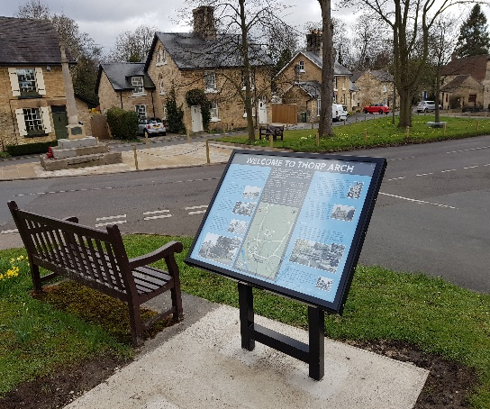

Website
A reminder that minutes and more details about the work of the Parish Council can be found on the website. Please visit at:
www.thorp-arch.org.uk

Dog Fouling on Dowkell Lane
The Parish Council have had a number of complaints about uncollected dog foul on Dowkell Lane. Please ensure you clear up after your dog. Fines are applicable for those who don’t.

Date of Next Parish Council Meeting
The next meeting will be held on Monday 8th April 7.00pm at: All Saints Church, Thorp Arch.

