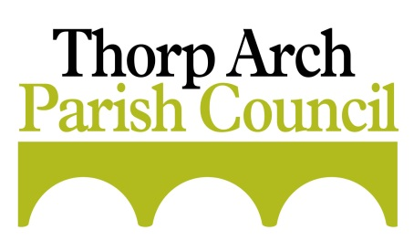
A message from Leeds City Council
Devolution Consultation

We hope you and your families are keeping well. While so much focus has shifted to Covid-19 related activity, in the background progress towards implementing the West Yorkshire devolution deal agreed in March has continued at pace. The deal, worth more than £1.8 billion, will see more decisions about the region taken here instead of London and more investment for the things that matter to local people.
In key areas for our future like transport, skills, the economy and climate change, responsibility will be transferred to people who know and understand our region, enabling us to move away from one-size-fits-all national approaches to deliver locally-focused decisions which will bring greater benefits for our communities and improve people’s quality of life. In the current context, the deal will also provide more essential funding and powers to help our region recover from the Covid-19 pandemic. This is one of the primary reasons why progress continues to be made quickly to ensure we are ready for a mayoral election in May 2021 to unlock the full potential of the deal.
A public consultation has now launched and will run until 19 July 2020 on the deal and proposals for a directly elected mayor. Please take part and share your views as part of this. There are a number of ways to engage:
• Through the online survey on the West Yorkshire Combined Authority website: www.yourvoice.westyorks-ca.gov.uk/WYdevolution
• By email to wyconsultation@ipsos-mori.com
• By calling the freephone telephone number 0800 141 3657
• By post using the freepost address: Freepost WY Devolution Consultation

.

