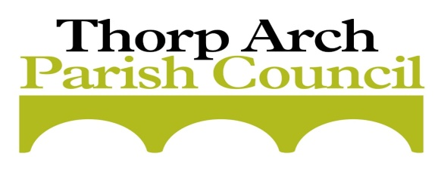

EXTRAORDINARY MINUTES OF THE MEETING OF THORP ARCH PARISH COUNCIL
HELD ON THURSDAY 19th MARCH 2020 6.30pm

PRESENT: Councillors: J. Richardson (JR) Chair, Nicola Midgely (NM), Ian Grainger (IG) Steve O’Loughlin (SOL), Andrew Peacock (AP).
IN ATTENDANCE: Tina Wormley
OTHERS: None

303 | PUBLIC REPRESENTATIONS  None
304 | TO APPROVE APOLOGIES FOR ABSENCE  None
305 | POSTPONING THE ANNUAL PARISH MEETING (APM)  Resolved to postpone the APM.
306 | DELEGATING OF DECISION MAKING TO AN OFFICER OF THE COUNCIL IE CLERK (LOCAL GOVERNMENT ACT 1972 SECTION 101) IN LIGHT OF THE COVID-19 VIRUS SITUATION  Resolved to extend the delegation of Council decisions to the Clerk during any period of restricted activity declared by the Government in respect of the Covid-19 virus. Such delegation should enable the Council to fulfil its responsibilities to its residents throughout the crisis. The Clerk will liaise with the Chairman and Vice Chairman on all decision and keep all Cllrs informed. A record of resolutions will be kept on file.
307 | CLOSURE  There being no further business, the Chairman declared the meeting closed at 7.30

Signed ……………………………………………….. Date………………………..

Chairman

Meeting conducted remotely due to Lockdown legislation during the Covid-19 virus outbreak.

