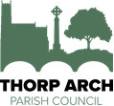
Parish Councillor Vacancies

Thorp Arch Parish Council has 2 vacancies. If you would like to get involved with your local community and make decisions for the benefit of your Parish both now and in the future, then please consider joining us. The role is both interesting and rewarding and an opportunity to contribute positively to your community.

Please contact the Clerk for further information, an informal discussion about the role, or to register your interest:
clerk@thorp-arch.org.uk

